Image Classification using CNN

Dataset
import kagglehub

# Download latest version
path = kagglehub.dataset_download("blourdhuraju/cifar-10")

print("Path to dataset files:", path)

Project Modules
Module 1: Data Collection
Load image dataset.
import numpy as np
import pandas as pd
import cv2
import matplotlib.pyplot as plt
from tensorflow.keras import datasets,layers,models
import random

import os

classname=["airplane","automobile","bird","cat","deer","dog","frog","horse","ship","truck"]
data_image="/root/.cache/kagglehub/datasets/blourdhuraju/cifar-10/versions/1/cifar10/test/train/0"
data_labels="/root/.cache/kagglehub/datasets/blourdhuraju/cifar-10/versions/1/cifar10/train_labels.csv"
traindata=[]

Module 2: Image Preprocessing
Resize images
Normalize images
Convert images into arrays

#Image Preprocessing
for file in os.listdir(data_image):

image_path = os.path.join(data_image, file)

image = cv2.imread(image_path)

if image is None:
continue
image = np.array(image)
#Resizing the image
image = cv2.resize(image, (10,10), interpolation=cv2.INTER_LINEAR)

traindata.append(image)

print("Total Images:", len(traindata))

train_image_path = '/root/.cache/kagglehub/datasets/blourdhuraju/cifar-10/versions/1/cifar10/test/train/0'
train_label_path = '/root/.cache/kagglehub/datasets/blourdhuraju/cifar-10/versions/1/cifar10/train_labels.csv'

train_images = [] #create an empty list
train_labels = []
# Define ClassNames using the existing 'classname' variable from the kernel state.
ClassNames = classname
# Sort files so image-label matching is correct
image_files = sorted(os.listdir(train_image_path))[:9]
label_files = pd.read_csv(train_label_path)[:9] #since file is csv, so used pandas to read file
#Now we need to read images
for file in image_files:

img_path = os.path.join(train_image_path, file)

image = cv2.imread(img_path)
#Need to convert BGR to RGB
image = cv2.cvtColor(image, cv2.COLOR_BGR2RGB)
#Now we have to resize the image to 64*64
image = cv2.resize(image, (64, 64))
image = image / 255.0 #Normalizing the image
train_images.append(image)
#Read the labels
for label_value in label_files['label']: #label is the column header
train_labels.append(label_value)
#we have to convert the python list to numpy arrays
train_images = np.array(train_images)
train_labels = np.array(train_labels)

print("Training Images Shape :", train_images.shape)
print("Training Labels Shape :", train_labels.shape)

plt.figure(figsize=(10, 5))
for i in range(len(train_images)):

plt.subplot(1, 9, i + 1)

plt.imshow(train_images[i])

plt.xticks([])
plt.yticks([])
#handle the outof range labels for plotting
label_idx = train_labels[i]
if 0 <= label_idx < len(ClassNames):
plt.xlabel(ClassNames[label_idx])
else:
plt.xlabel(f"Invalid Label: {label_idx}")

plt.show()

test_image_path = '/root/.cache/kagglehub/datasets/blourdhuraju/cifar-10/versions/1/cifar10/test/train/0'
test_label_path = '/root/.cache/kagglehub/datasets/blourdhuraju/cifar-10/versions/1/cifar10/train_labels.csv'

test_images = []
test_labels = []

image_files = sorted(os.listdir(test_image_path))[:9]
label_files = pd.read_csv(test_label_path)[:9]
#Now read the test images
for file in image_files:

img_path = os.path.join(test_image_path, file)

image = cv2.imread(img_path)

image = cv2.cvtColor(image, cv2.COLOR_BGR2RGB)

image = cv2.resize(image, (64, 64))

image = image / 255.0

test_images.append(image)
#now read the testt labels
for label_value in label_files['label']:
test_labels.append(label_value)
#converting to numpy arrays
test_images = np.array(test_images)
test_labels = np.array(test_labels)

print("Testing Images Shape :", test_images.shape)
print("Testing Labels Shape :", test_labels.shape)
#CNN Model Building
#Module 3: CNN Model Building
#Build layers:
#Convolution layer
#Max pooling layer
#Flatten layer
#Dense layer
model = models.Sequential([

layers.Input(shape=(64, 64, 3)),

layers.Conv2D(32, (3, 3), activation='relu'),
layers.MaxPooling2D((2, 2)),

layers.Conv2D(64, (3, 3), activation='relu'),
layers.MaxPooling2D((2, 2)),

layers.Conv2D(64, (3, 3), activation='relu'),

layers.Flatten(),

layers.Dense(64, activation='relu'),

layers.Dense(10, activation='softmax')
])

model.compile(
optimizer='adam',
loss='sparse_categorical_crossentropy',
metrics=['accuracy']
)

model.summary()

#Module 4: Model Training
#Train the CNN model.
history = model.fit(
train_images,
train_labels,
epochs=20,
batch_size=2,
validation_data=(test_images, test_labels)
)
#Module 5: Evaluation
#Evaluate accuracy and loss.
loss, accuracy = model.evaluate(test_images, test_labels)

print("\nTest Loss :", loss)
print("Test Accuracy :", accuracy)

model.save("ShipClassifierV1.h5")

print("\nModel Saved Successfully")

model = models.load_model("ShipClassifierV1.h5")

print("\nModel Loaded Successfully")

plt.figure(figsize=(12, 12))

for i in range(9):

plt.subplot(8, 8, i + 1)

plt.imshow(test_images[i])

plt.xticks([])
plt.yticks([])

#Module 6: Prediction
#Predict image classes
# Prediction
pred = model.predict(np.array([test_images[i]]), verbose=0)

index = np.argmax(pred)
# Handle out-of-range labels for plotting
actual_label_text = f"Invalid Label: {test_labels[i]}"
if 0 <= test_labels[i] < len(ClassNames):
actual_label_text = ClassNames[test_labels[i]]

predicted_label_text = f"Invalid Label: {index}"
if 0 <= index < len(ClassNames):
predicted_label_text = ClassNames[index]

plt.xlabel(
f"Actual = {actual_label_text}\nPredicted = {predicted_label_text}"
)

plt.tight_layout()
plt.show()

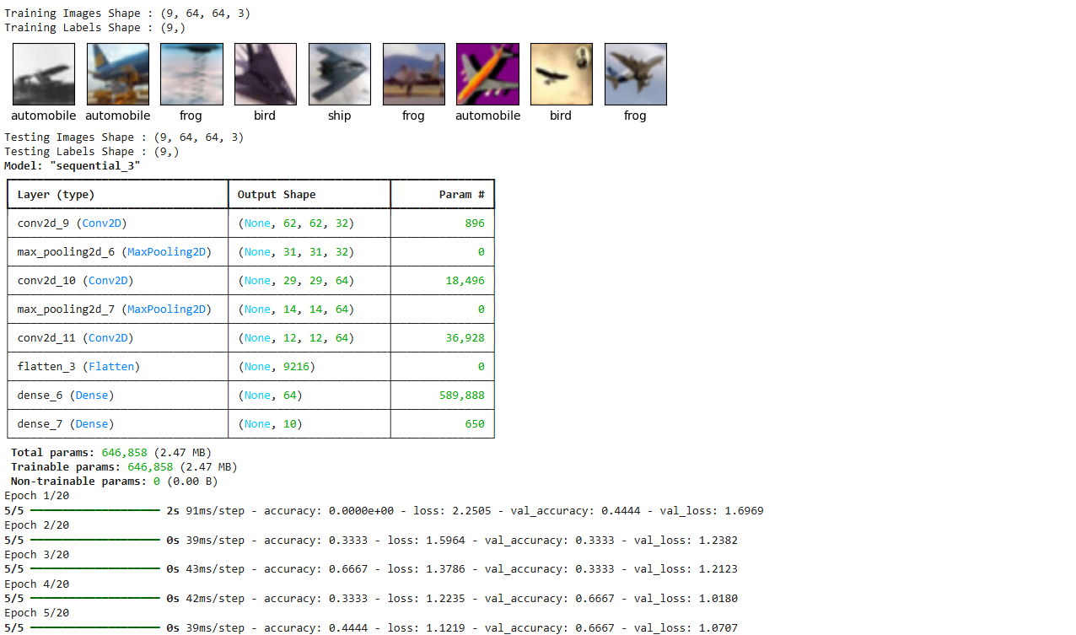
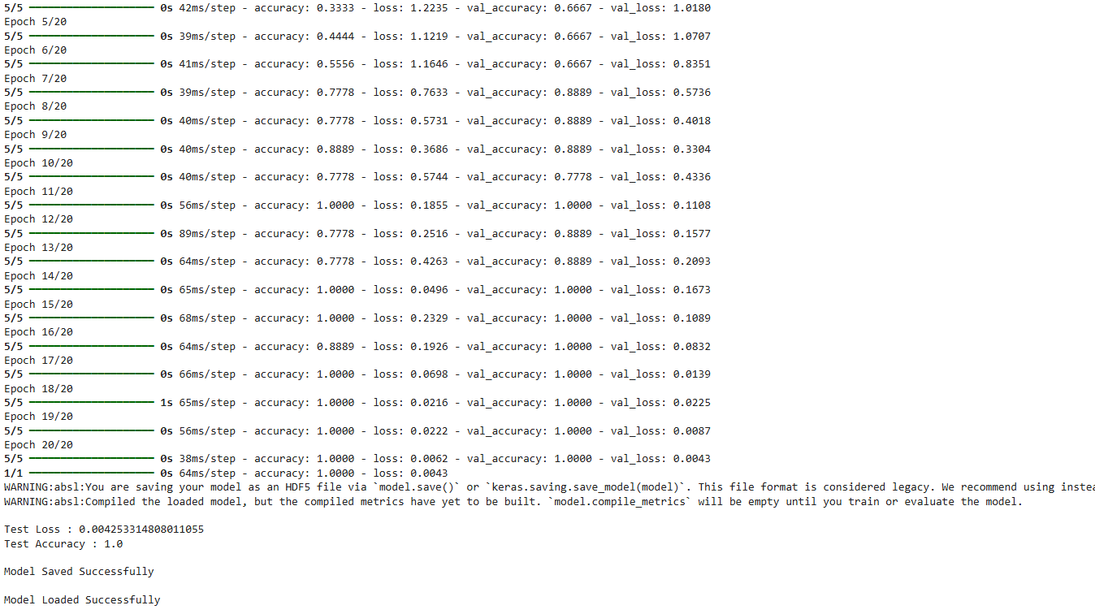
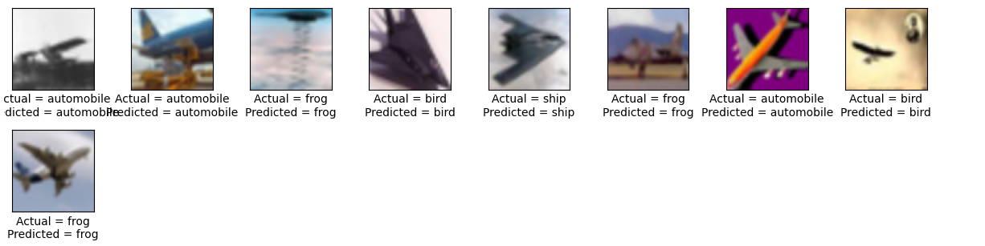

Viva Questions
What is CNN?
A CNN is a deep learning model that uses convolutional layers to automatically learn spatial hierarchies of features from input data (like edges, textures, shapes). It is used in Image classification, object detection, medical imaging, NLP, and even financial time series. CNNs require fewer parameters than fully connected ANNs, making them efficient and less prone to overfitting.
What is convolution?
Convolution is a mathematical operation where a small filter (kernel) slides over the input (image or signal) and computes weighted sums. It extracts local features like edges, corners, and textures. It produces a feature map that highlights important patterns in the input.

What is pooling?
Pooling reduces the spatial dimensions of feature maps while retaining essential information. There are three types.
*Max pooling: Takes the maximum value in a region (captures strongest features).
*Average pooling: Takes the average value
*Global pooling: Reduces entire feature map to one value.

Why do we use activation functions?
The purpose of activation functions is to introduce non-linearity so the network can learn complex patterns. The network would behave like a linear regression model, unable to capture non-linear relationships. The common functions are:
Sigmoid: Outputs between 0 and 1 (good for probabilities).
Tanh: Outputs between -1 and 1 (centers data).
ReLU: Outputs positive values directly, zero otherwise (fast and widely used)

Difference between CNN and ANN?
Feature | CNN | ANN
Input type | Images, signals, spatial data | Tabular data, general features
Architecture | Convolutional + pooling + fully connected layers | Fully connected layers only
Feature extraction | Automatic via filters | Manual or requires preprocessing
Parameters | Fewer (shared weights) | Many (dense connections)
Efficiency | High for image tasks | Less efficient for large images
Applications | Image recognition, object detection, NLP | Regression, classification (non-image)

Colab link
https://colab.research.google.com/drive/1r-DjJ_-WQE8I2n6DKruLBmnaOS0vY4yF?usp=sharing

